# Charting the Course of Innovation: A Startup Analysis

Starting a new company can be an exciting and rewarding experience, but it also requires careful planning and analysis to ensure that the business is viable and successful. There are several key areas that you should focus on when conducting a startup company analysis. Conducting a thorough analysis of these areas can help you identify potential challenges and opportunities, and develop strategies to address them. It is also important to regularly review and update your analysis as the business progresses, in order to adapt to changing market conditions.

### Milestone 1: Define Problem / Problem Understanding

**Activity 1: Specify the business problem**

Refer Project Description

#### Activity 2: Business requirements

The business requirements for analyzing the performance and efficiency of startups in India include identifying KPIs, comparing performance across different industries and states, identifying patterns and trends over time, identifying affecting factors, creating interactive dashboards and reports, identifying areas for improvement, making data-driven decisions, comparing to the industry average and creating forecasting models for future performance. The ultimate goal is to gain insights and improve performance through data visualization techniques.

#### Activity 3: Literature Survey (Student Will Write)

A literature survey is a method of researching existing literature and studies related to a specific topic. In the context of analyzing the performance and efficiency of startups in India, a literature survey would involve reviewing studies and articles that have been published on the topic of hotel performance and efficiency, as well as studies specific to startups approved by the Indian government.The literature survey would include sources such as academic journals, industry reports, and online articles. It would aim to identify key performance indicators (KPIs) and metrics that are commonly used to measure startup culture and its trend, as well as any best practices or strategies that have been identified for improving performance. The literature survey would also explore any existing research on startups in India of different domains specifically and would aim to identify any unique challenges or opportunities that the hotel chain faces in terms of performance and efficiency

**Activity 4: Social or Business Impact.**

Social Impact: Startups are the boost for any country. By analysing the startups and number of startups coming every year and industries that are seeing the boom, may somebody with the dilemma to start or not start can start his/her own company and become successful.

Business Model/Impact: Can make this visualization application available for people, for more insights and ideas can ask for payment and also can give these insights to investors and banks to make the understand and help in the sense of investing.

### Milestone 2: Data Collection & Extraction from Database

Data collection is the process of gathering and measuring information on variables of interest, in an established systematic fashion that enables one to answer stated research questions, test hypotheses, evaluate outcomes and generate insights from the data.

### Milestone 1: Define Problem / Problem Understanding

**Activity 1: Specify the business problem**

Refer Project Description

#### Activity 2: Business requirements

The business requirements for analyzing the performance and efficiency of startups in India include identifying KPIs, comparing performance across different industries and states, identifying patterns and trends over time, identifying affecting factors, creating interactive dashboards and reports, identifying areas for improvement, making data-driven decisions, comparing to the industry average and creating forecasting models for future performance. The ultimate goal is to gain insights and improve performance through data visualization techniques.

#### Activity 3: Literature Survey (Student Will Write)

A literature survey is a method of researching existing literature and studies related to a specific topic. In the context of analyzing the performance and efficiency of startups in India, a literature survey would involve reviewing studies and articles that have been published on the topic of hotel performance and efficiency, as well as studies specific to startups approved by the Indian government.The literature survey would include sources such as academic journals, industry reports, and online articles. It would aim to identify key performance indicators (KPIs) and metrics that are commonly used to measure startup culture and its trend, as well as any best practices or strategies that have been identified for improving performance. The literature survey would also explore any existing research on startups in India of different domains specifically and would aim to identify any unique challenges or opportunities that the hotel chain faces in terms of performance and efficiency

**Activity 4: Social or Business Impact.**

Social Impact: Startups are the boost for any country. By analysing the startups and number of startups coming every year and industries that are seeing the boom, may somebody with the dilemma to start or not start can start his/her own company and become successful.

Business Model/Impact: Can make this visualization application available for people, for more insights and ideas can ask for payment and also can give these insights to investors and banks to make the understand and help in the sense of investing.

### Milestone 2: Data Collection & Extraction from Database

Data collection is the process of gathering and measuring information on variables of interest, in an established systematic fashion that enables one to answer stated research questions, test hypotheses, evaluate outcomes and generate insights from the data.

**Activity 1.1: Understand the data**

Data contains all the meta information regarding the columns described in the CSV files

**Column Description of the Dataset:**

1. date: This column represents the dates present in May, June and July.
2. mmm yy: This column represents the date in the format of mmm yy (monthname year).
3. week no: This column represents the unique week number for that particulardate.
4. day_type: This column represents whether the given day is a Weekend or aWeekday.

#### Activity 2: Storing Data in DB & Perform SQL Operations

#### Activity 3: Connect DB with Tableau

### Milestone 3: Data Preparation

#### Activity 1: Prepare the Data for Visualization

Preparing the data for visualization involves cleaning the data to remove irrelevant or missing data, transforming the data into a format that can be easily visualized, exploring the data to identify patterns and trends, filtering the data to focus on specific subsets of data, preparing the data for visualization software, and ensuring the data is accurate and complete. This process helps to make the data easily understandable and ready for creating visualizations to gain insights into the performance and efficiency.

### Milestone 4: Data Visualization

Data visualization is the process of creating graphical representations of data to help people understand and explore the information. The goal of data visualization is to make complex data sets more accessible, intuitive, and easier to interpret. By using visual elements such as charts, graphs, and maps, data visualizations can help people quickly identify patterns, trends, and outliers in the data.

#### Activity 1: No of Unique Visualizations

The number of unique visualizations that can be created with a given dataset. Some common types of visualizations that can be used to analyze the performance and efficiency of Radisson Hotels include bar charts, line charts, heat maps, scatter plots, pie charts,Maps etc. These visualizations can be used to compare performance, track changes over time, show distribution, and relationships between variables, breakdown of revenue and customer demographics, workload, resource allocation and location of hotels. **Activity 1.1: Number of Startups by Year**

**Activity 1.2: Number of Startups Industry Wise**

**Activity 1.3: Number of startups by state**

**Activity 1.4: Top 10 Industries by no of startups**

**Activity 1.5: Number of Startups by year and applying filers of Industry and State**

**Activity 1.6: Top 10 Industries by no of Startups**

**Activity 1.7: Top 10 Industries and Top 10 States of each industry**

### Milestone 5: Dashboard

A dashboard is a graphical user interface (GUI) that displays information and data in an organized, easy-to-read format. Dashboards are often used to provide real-time monitoring and analysis of data and are typically designed for a specific purpose or use case. Dashboards can be used in a variety of settings, such as business, finance, manufacturing, healthcare, and many other industries. They can be used to track key performance indicators (KPIs), monitor performance metrics, and display data in the form of charts, graphs, and tables.

#### Activity 1- Responsive and Design of Dashboard

Once you have created views on different sheets in Tableau, you can pull them into a dashboard.

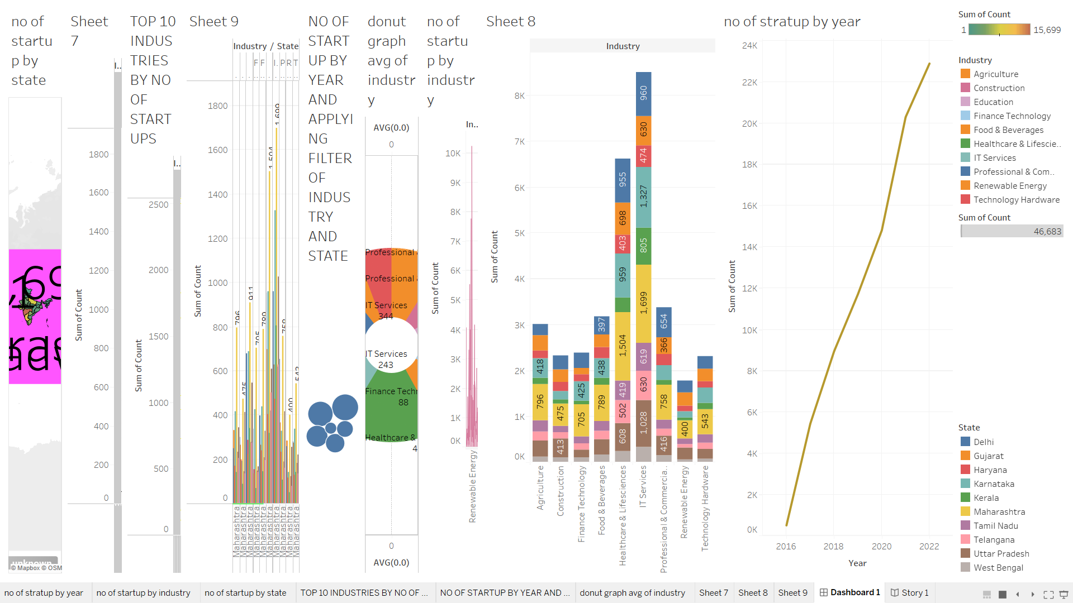

## Milestone 6: Story

A data story is a way of presenting data and analysis in a narrative format, intending to make the information more engaging and easier to understand. A data story typically includes a clear introduction that sets the stage and explains the context for the data, a body that presents the data and analysis logically and systematically, and a conclusion that summarizes the key findings and highlights their implications. Data stories can be told using a variety of mediums, such as reports, presentations, interactive visualizations, and videos.

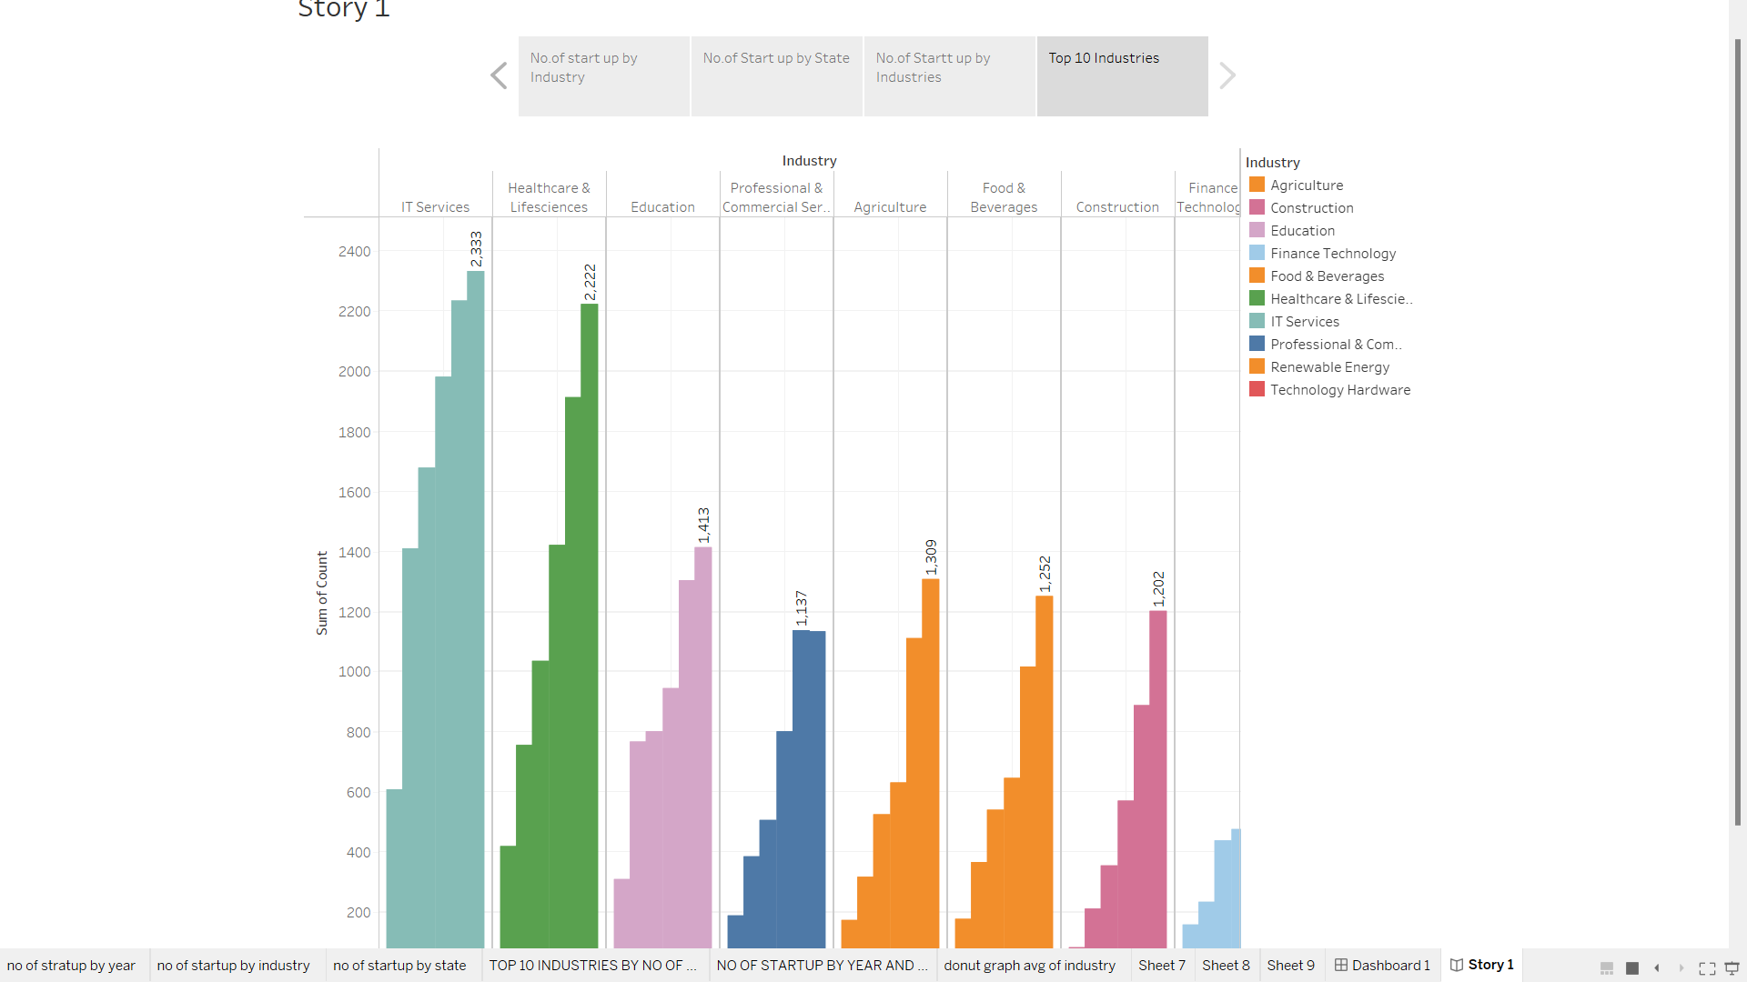

### Activity 1- No of Scenes of Story

The number of scenes in a storyboard for a data visualization analysis of the performance and efficiency of Radisson Hotels will depend on the complexity of the analysis and the specific insights that are trying to be conveyed. A storyboard is a visual representation of the data analysis process and it breaks down the analysis into a series of steps or scenes.

### Milestone 7: Performance Testing

#### Activity 1: Amount of Data Rendered to DB

* The amount of data that is rendered to a database depends on the size of the dataset and the capacity of the database to store and retrieve data.
* Open the MySQL Workbench, go to the database then click to expand the tables,select the table and click on (i) button to get the information related to table such as column count,table rows etc.

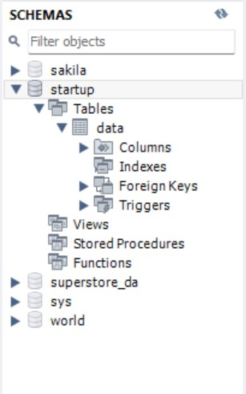

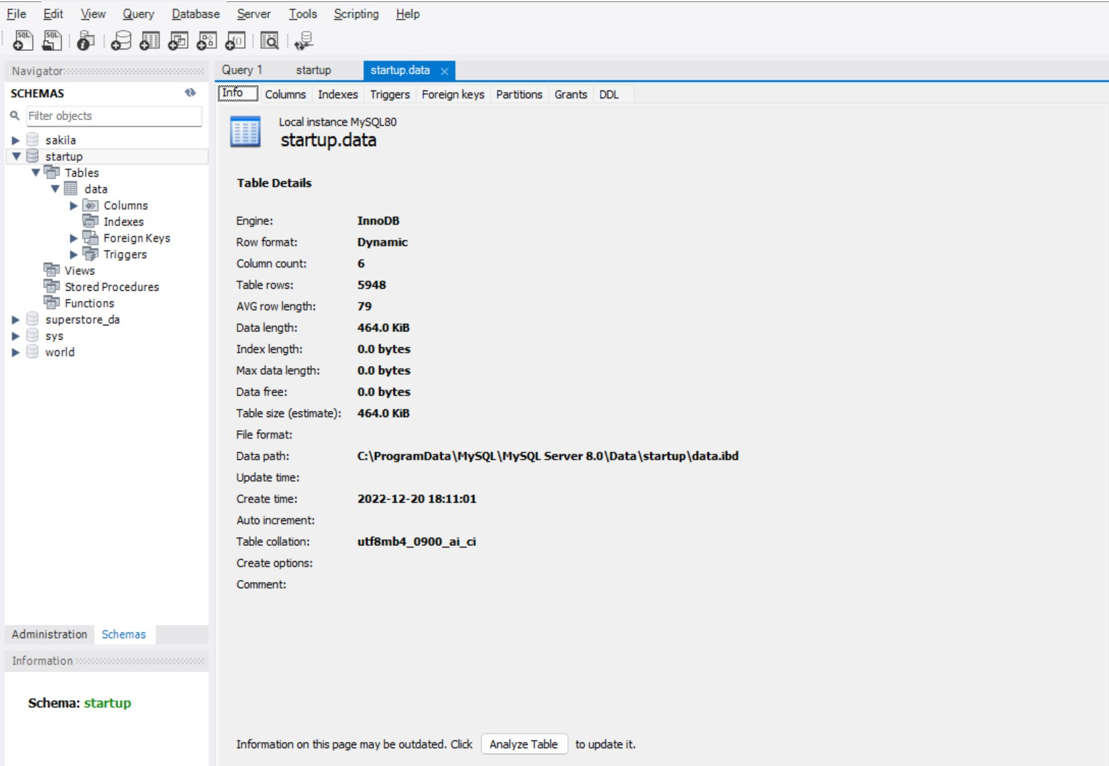

#### Activity 2: Utilization of Data Filters

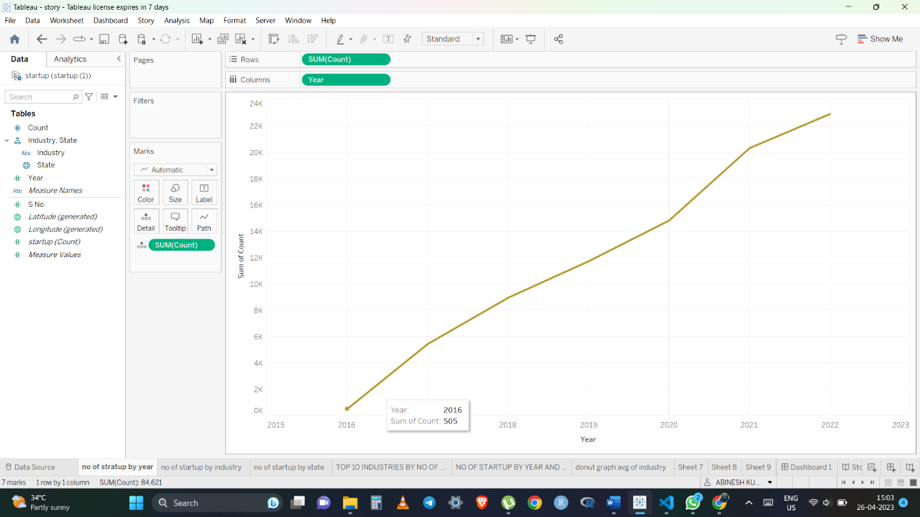

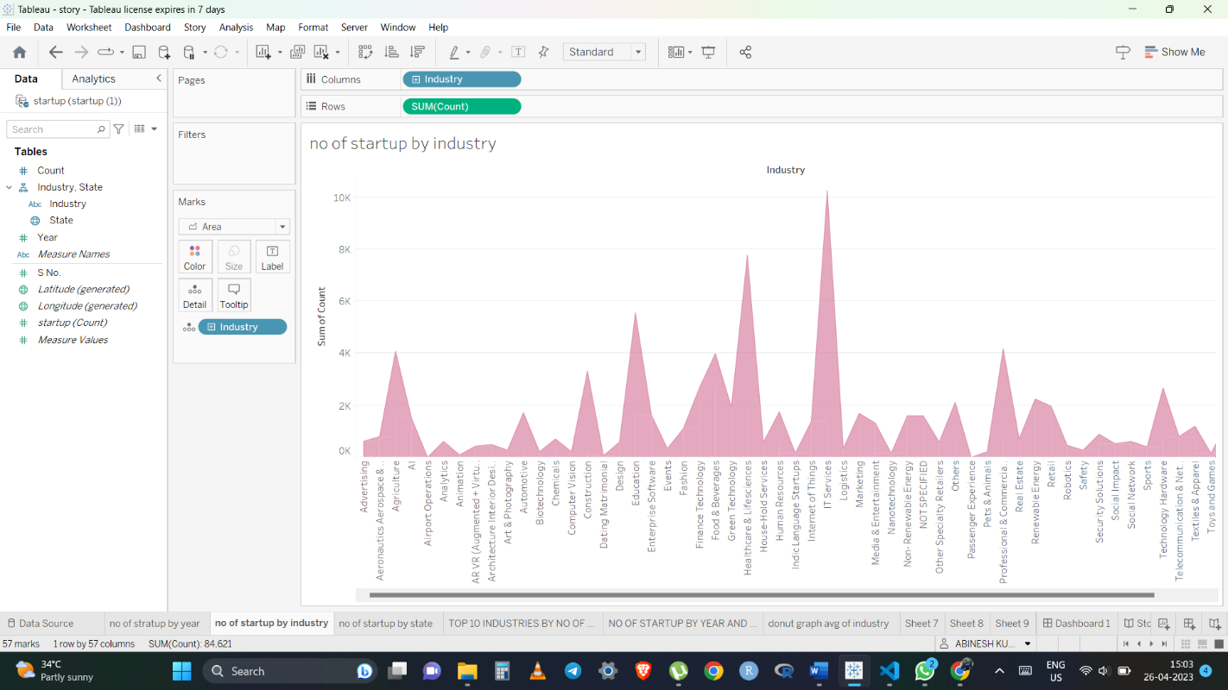

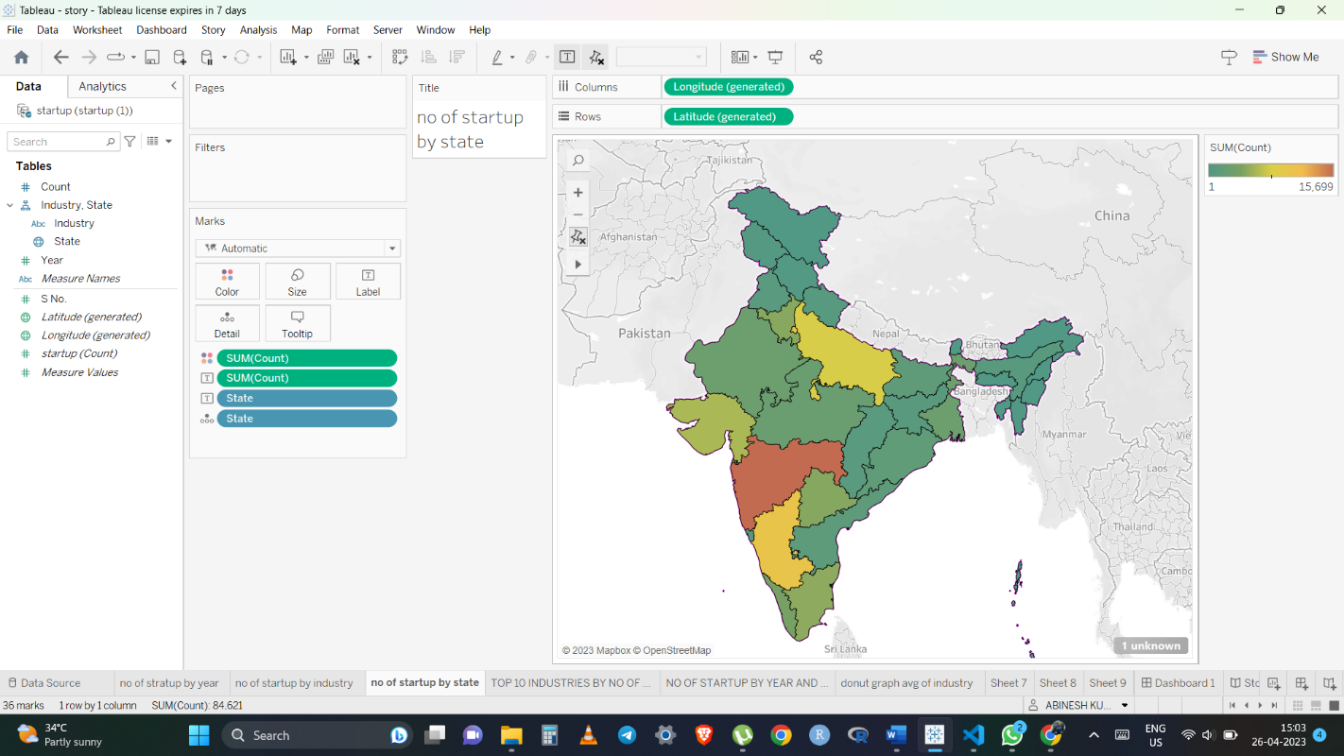

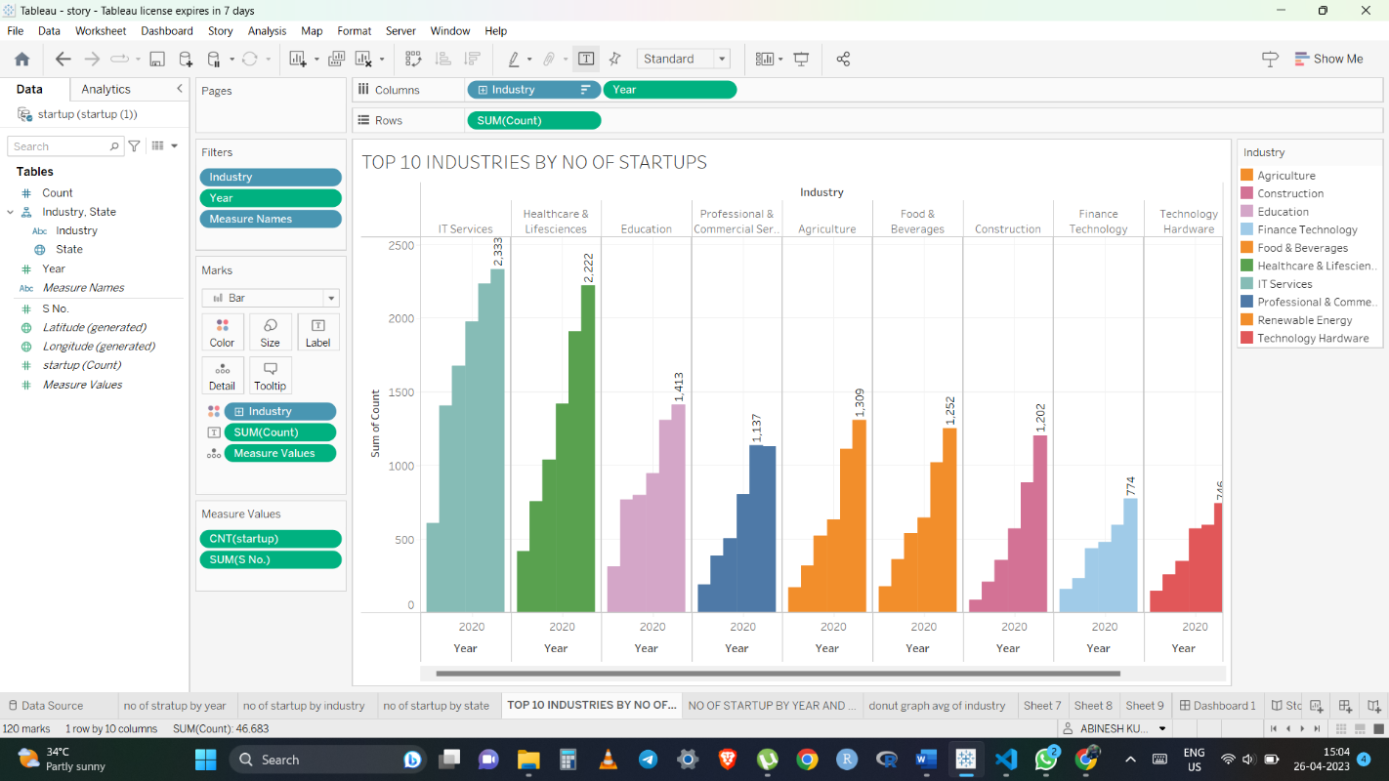

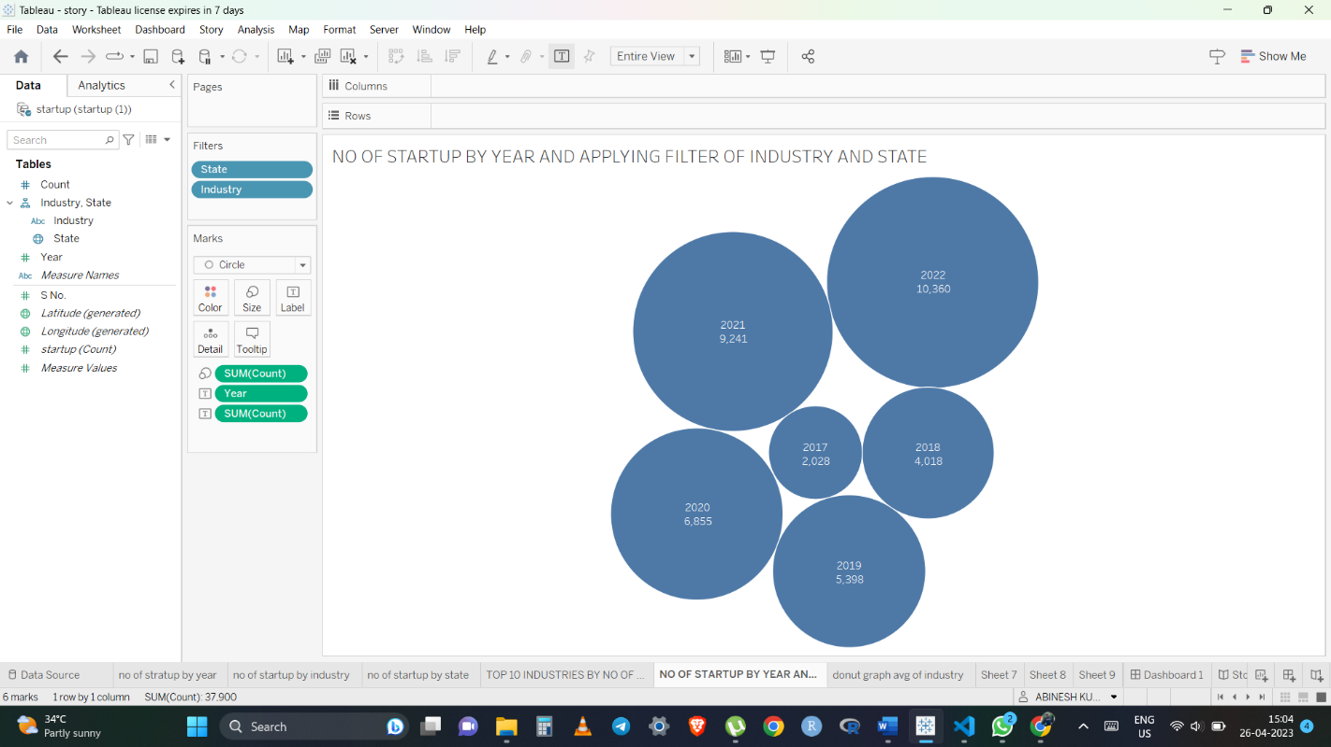

#### Activity 3: No of Calculation Fields

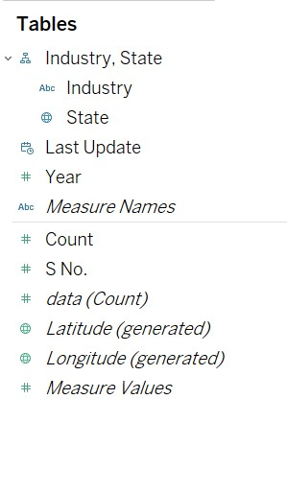

#### Activity 4: No of Visualizations/ Graphs

1. Number of Startups by Year
2. Number of Startups industry Wise
3. Number of startups by state
4. Top 10 Industry by no of startups
5. Number of Startups by year and applying filers of Industry and State
6. Top 10 Industries by no of Startups
7. Top 10 Industries and Top 10 States of each industry

### Milestone 8: Web integration

Publishing helps us to track and monitor key performance metrics and to communicate results and progress. help a publisher stay informed, make better decisions, and communicate their performance to others.

**Publishing dashboard and reports to tableau public**

**Step 1**: Go to Dashboard/story, click on the share button on the top ribbon

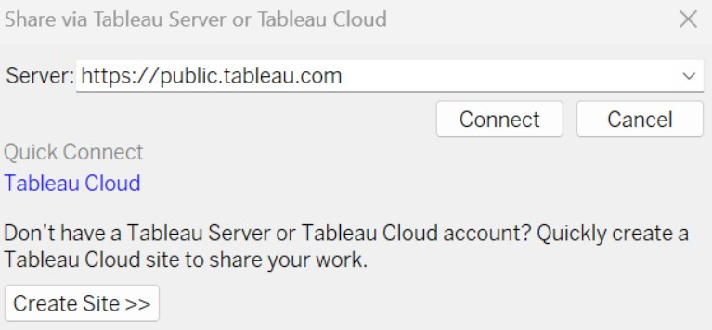

Give the server address of your tableau public account and click on connect.

**Step 2:** Once you click on connect it will ask you for the tableau public username and password

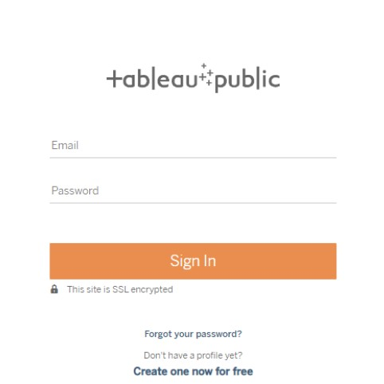

Once you login into your tableau public using the credentials, the particular visualization will be published into the tableau public

**Note: While publishing the visualization to the public, the respective sheet will get published when you click on the share option.**

#### Activity 1: Embed Dashboard & Story with Web Bootstrap

## 

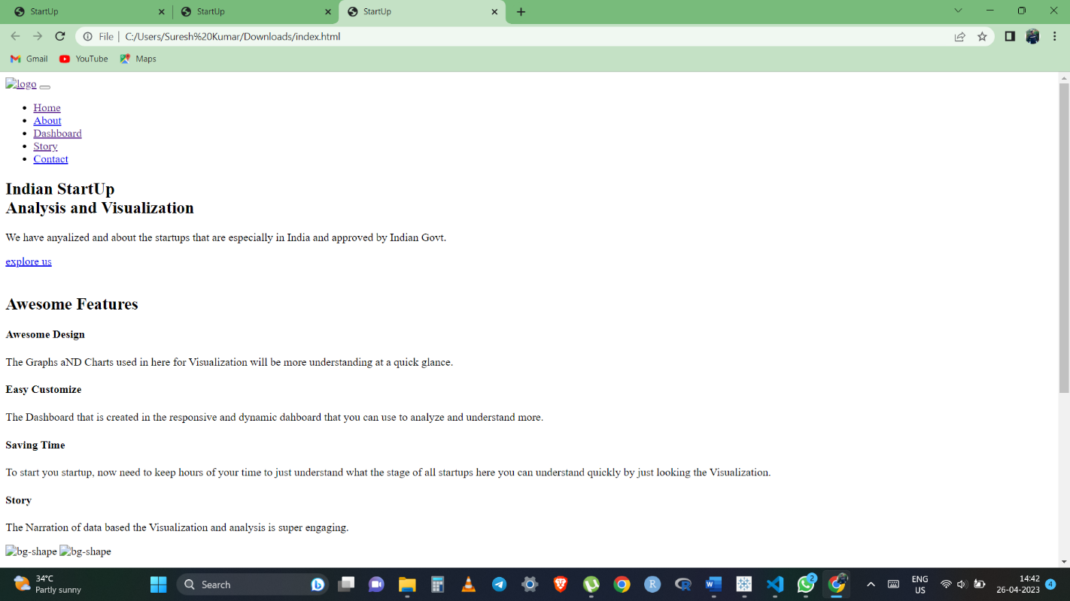

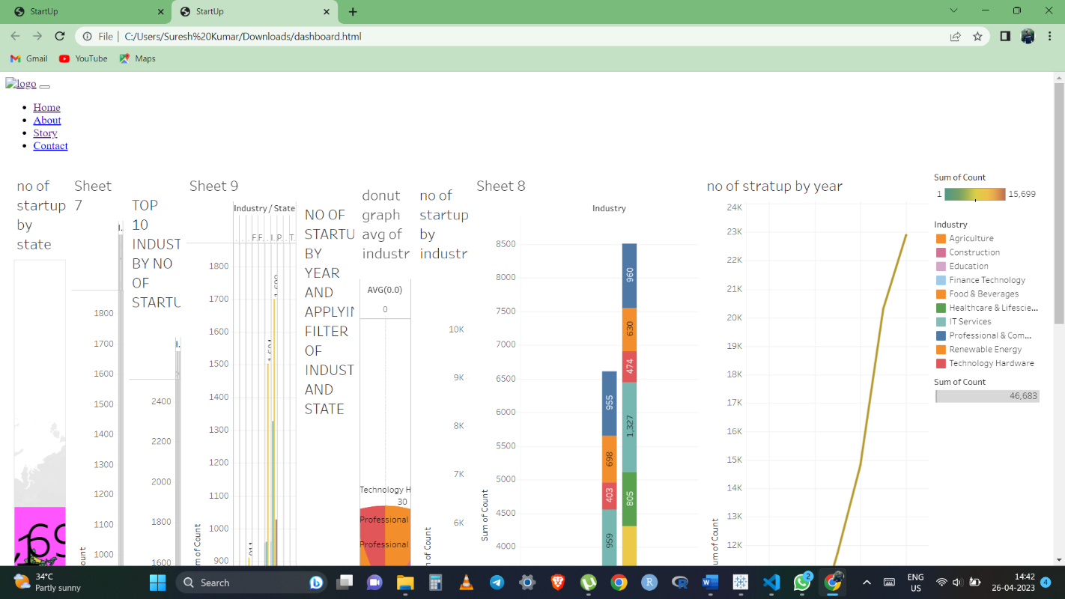

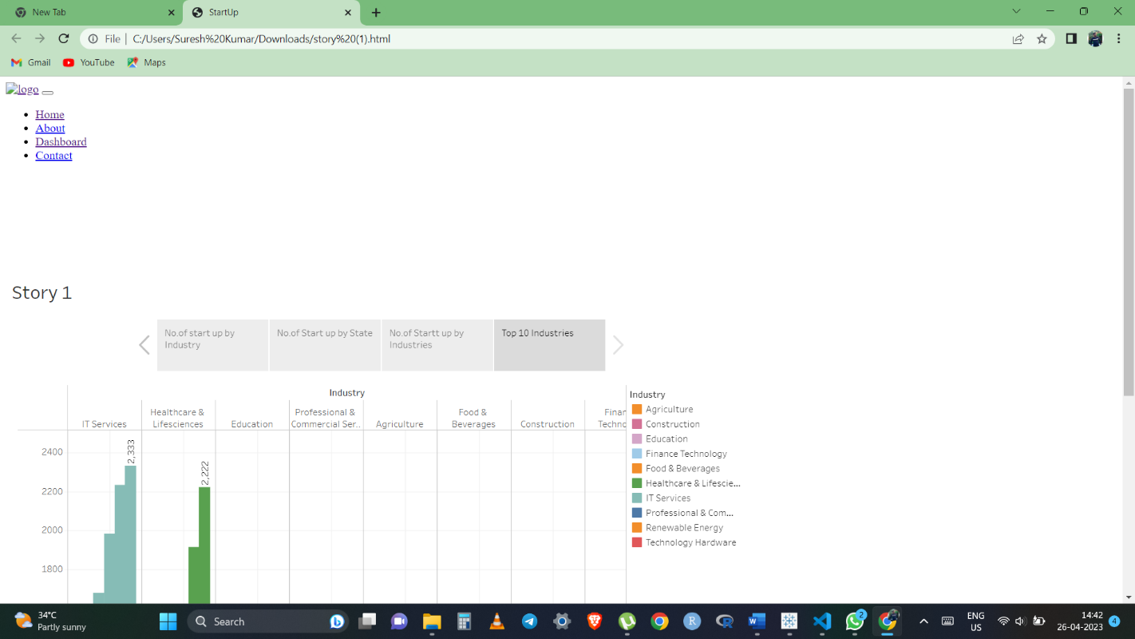

### Milestone 9: Project Demonstration & Documentation

Below mentioned deliverables to be submitted along with other deliverables

**Activity 1:- Record explanation Video for the project's end-to-end solution**

#### Activity 2:- Project Documentation-Step by step project development procedure

Create document as per the template pr